ASSIGNMENT 2

Q1. Printing your machine’s name and IPv4 address?

import socket
import fcntl
import struct

def get_ip_address(ifname):
s = socket.socket(socket.AF_INET, socket.SOCK_DGRAM)
return socket.inet_ntoa(fcntl.ioctl(
s.fileno(),
0x8915, # SIOCGIFADDR
struct.pack('256s', ifname[:15])
)[20:24])

hostname = socket.gethostname()
print("Mahcine Name is: " + hostname)
print("Machine IPv4 Address is: " + get_ip_address('eth0'))

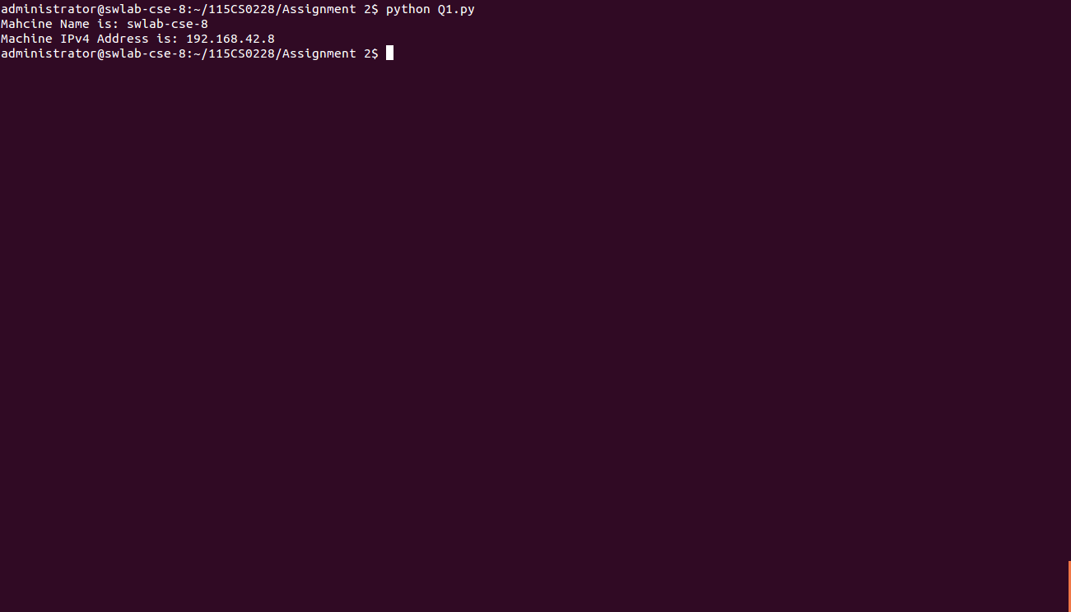
Q2. Retrieve a remote machine’s IP address and convert the IP address to
different format?

import socket
from binascii import hexlify
def get_remote_machine_details():
remote_host = "www.nitrkl.ac.in"
ip_addr = socket.gethostbyname(remote_host)
try:
print "IP address of "+remote_host+" : "+ip_addr
return ip_addr
except socket.error, err_msg:
print "%s: %s" %(remote_host, err_msg)

def convert_ip_addr(ip_addr):
packed_ip_addr = socket.inet_aton(ip_addr)
unpacked_ip_addr = socket.inet_ntoa(packed_ip_addr)
print "IP Address: %s => Packed: %s, Unpacked: %s"\
%(ip_addr, hexlify(packed_ip_addr), unpacked_ip_addr)

ip_addr = get_remote_machine_details()
convert_ip_addr(ip_addr)

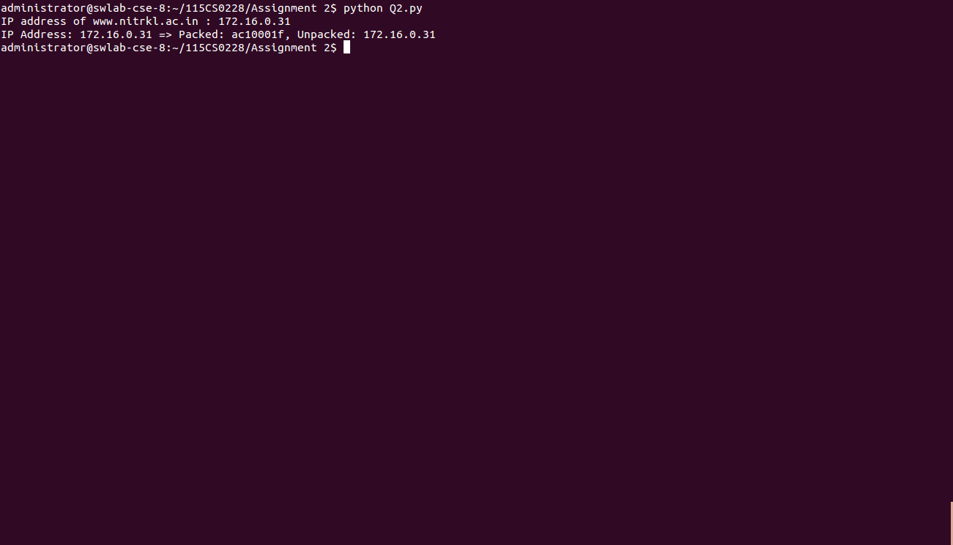
Q3. Setting and getting the default socket timeout, the program should include how to handle the socket error gracefully?

import sys
import socket
import argparse

def socket_timeout():
s = socket.socket(socket.AF_INET, socket.SOCK_STREAM)
print "Default socket timeout: %s" %s.gettimeout()
s.settimeout(20)
print "Current socket timeout: %s" %s.gettimeout()

def socket_error():
# setup argument parsing
parser = argparse.ArgumentParser(description='Socket Error Examples')
parser.add_argument('--host', action="store", dest="host",required=False)
parser.add_argument('--port', action="store", dest="port",type=int, required=False)
parser.add_argument('--file', action="store", dest="file",required=False)
given_args = parser.parse_args()
host = given_args.host
port = given_args.port
filename = given_args.file
# First try-except block -- create socket
try:
s = socket.socket(socket.AF_INET, socket.SOCK_STREAM)
except socket.error, e:
print "Error creating socket: %s" % e
sys.exit(1)
# Second try-except block -- connect to given host/port
try:
s.connect((host, port))
except socket.gaierror, e:
print "Address-related error connecting to server: %s" % e
sys.exit(1)
except socket.error, e:
print "Connection error: %s" % e
sys.exit(1)
# Third try-except block -- sending data
try:
s.sendall("GET %s HTTP/1.0\r\n\r\n" % filename)
except socket.error, e:
print "Error sending data: %s" % e
sys.exit(1)
while 1:
# Fourth try-except block -- waiting to receive data from remote host
try:
buf = s.recv(2048)
except socket.error, e:
print "Error receiving data: %s" % e
sys.exit(1)
if not len(buf):
break
# write the received data
sys.stdout.write(buf)

socket_timeout()

socket_error()
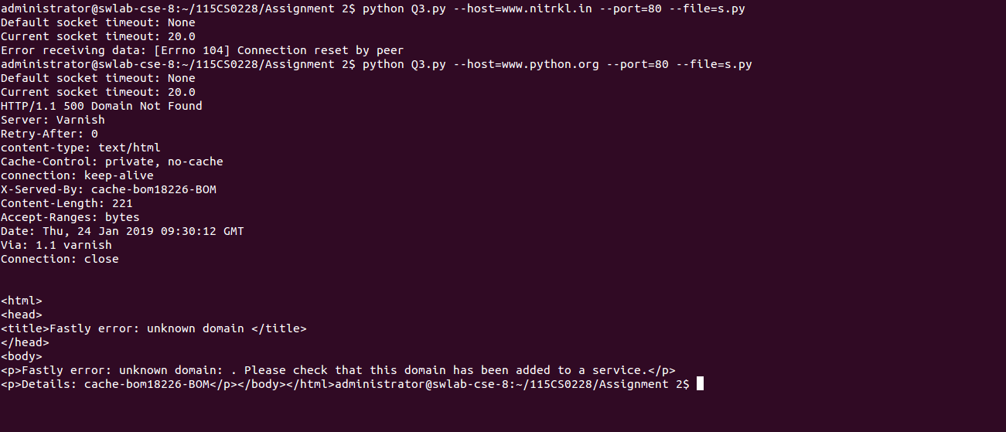
Q4. Finding the service name, given the port and protocol of the remote host
(server)?

import socket
def get_service_name():
protocolname = 'tcp'
for port in [80, 25]:
print "Port: %s => service name: %s" %(port, socket.getservbyport(port, protocolname))
print "Port: %s => service name: %s" %(53, socket.getservbyport(53, 'udp'))

get_service_name()

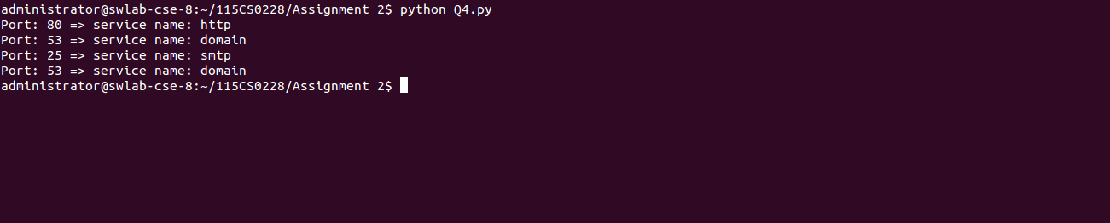
Q5. Printing the current time from the internet time server with the help of NTP? Also write an SNTP client that prints the current time from the internet time server received with the SNTP protocol?

import socket
import struct
import sys
import time
import ntplib
from time import ctime

def get_time():
c = ntplib.NTPClient()
response = c.request('pool.ntp.org')
print(ctime(response.tx_time))

def sntp_client():
NTP_SERVER = "0.uk.pool.ntp.org"
TIME1970 = 2208988800L
client = socket.socket(socket.AF_INET, socket.SOCK_DGRAM)
data = '\x1b' + 47 * '\0'
client.sendto(data, (NTP_SERVER, 123))
data, address = client.recvfrom( 1024 )
if data:
print 'Response received from:', address
t = struct.unpack( '!12I', data )[10]
t -= TIME1970
print '\tTime=%s' % time.ctime(t)

sntp_client()
get_time()

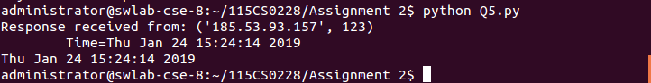
Q6. Modifying sockets send/receive buffer size and changing the socket to
blocking/non‐blocking mode?

import socket

SEND_BUF_SIZE = 4096
RECV_BUF_SIZE = 4096

def update_buffer():
sck = socket.socket(socket.AF_INET, socket.SOCK_STREAM )
# Get the size of the socket's send buffer
bufsize = sck.getsockopt(socket.SOL_SOCKET, socket.SO_SNDBUF)
print "Intial Buffer size :%d" %bufsize
sck.setsockopt(socket.SOL_TCP, socket.TCP_NODELAY, 1)
sck.setsockopt(socket.SOL_SOCKET,socket.SO_SNDBUF,SEND_BUF_SIZE)
sck.setsockopt(socket.SOL_SOCKET,socket.SO_RCVBUF,RECV_BUF_SIZE)
bufsize = sck.getsockopt(socket.SOL_SOCKET, socket.SO_SNDBUF)
print "Updated Buffer size :%d" %bufsize

def block_modes():
s = socket.socket(socket.AF_INET, socket.SOCK_STREAM)
s.setblocking(1)
s.settimeout(0.5)
s.bind(("127.0.0.1", 0))
socket_address = s.getsockname()
print "Trivial Server launched on socket: %s" %str(socket_address)
#while(1):
#s.listen(1)

update_buffer()
block_modes()
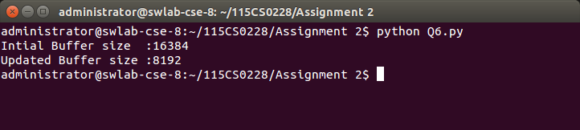
Q7. Write a program that demonstrates the reuse socket addresses?

import socket
import sys
def socket_reuse():
sock = socket.socket( socket.AF_INET, socket.SOCK_STREAM )
# Get the old state of the SO_REUSEADDR option
old_state = sock.getsockopt(socket.SOL_SOCKET, socket.SO_REUSEADDR)
print "Old sock state: %s" %old_state
# Enable the SO_REUSEADDR option
sock.setsockopt( socket.SOL_SOCKET, socket.SO_REUSEADDR, 1 )
new_state = sock.getsockopt( socket.SOL_SOCKET, socket.SO_REUSEADDR )
print "New sock state: %s" %new_state
local_port = 8282
srv = socket.socket(socket.AF_INET, socket.SOCK_STREAM)
srv.setsockopt(socket.SOL_SOCKET, socket.SO_REUSEADDR, 1)
srv.bind( ('', local_port) )
srv.listen(1)
print ("Listening on port: %s " %local_port)
while True:
try:
connection, addr = srv.accept()
print 'Connected by %s:%s' % (addr[0], addr[1])
except KeyboardInterrupt:
break
except socket.error, msg:
print '%s' % (msg,)

socket_reuse()
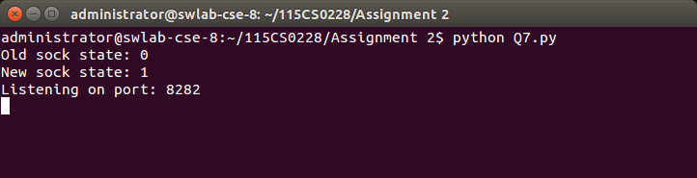
Q8. Write a simple TCP echo client/server application with the help of TCP socket object. The server wait for the client to be connected and send some data to the server. When the data is received, the server echoes the data to the client.

SERVER.PY
import socket
import sys
import argparse
host = 'localhost'
data_payload = 2048
backlog = 5

def echo_server(port):
""" A simple echo server """
# Create a TCP socket
sock = socket.socket(socket.AF_INET, socket.SOCK_STREAM)
# Enable reuse address/port
sock.setsockopt(socket.SOL_SOCKET, socket.SO_REUSEADDR, 1)
# Bind the socket to the port
server_address = (host, port)
print "Starting up echo server on %s port %s" % server_address
sock.bind(server_address)
# Listen to clients, backlog argument specifies the max no. of queued connections
sock.listen(backlog)
while True:
print "Waiting to receive message from client"
client, address = sock.accept()
data = client.recv(data_payload)
if data:
print "Data: %s" %data
client.send(data)
print "sent %s bytes back to %s" % (data, address)
# end connection
client.close()

if __name__ == '__main__':
parser = argparse.ArgumentParser(description='Socket Server Example')
parser.add_argument('--port', action="store", dest="port",type=int, required=True)
given_args = parser.parse_args()
port = given_args.port
echo_server(port)

CLIENT.PY
import socket
import sys
import argparse
host = 'localhost'
def echo_client(port):
# Create a TCP/IP socket
sock = socket.socket(socket.AF_INET, socket.SOCK_STREAM)
# Connect the socket to the server
server_address = (host, port)
print "Connecting to %s port %s" % server_address
sock.connect(server_address)
# Send data
try:
# Send data
message = "Echo message"
print "Sending %s" % message
sock.sendall(message)
# Look for the response
amount_received = 0
amount_expected = len(message)
while amount_received < amount_expected:
data = sock.recv(16)
amount_received += len(data)
print "Received: %s" % data
except socket.errno, e:
print "Socket error: %s" %str(e)
except Exception, e:
print "Other exception: %s" %str(e)
finally:
print "Closing connection to the server"
sock.close()

if __name__ == '__main__':
parser = argparse.ArgumentParser(description='Socket Server Example')
parser.add_argument('--port', action="store", dest="port",type=int, required=True)
given_args = parser.parse_args()
port = given_args.port
echo_client(port)
CLIENT SIDE
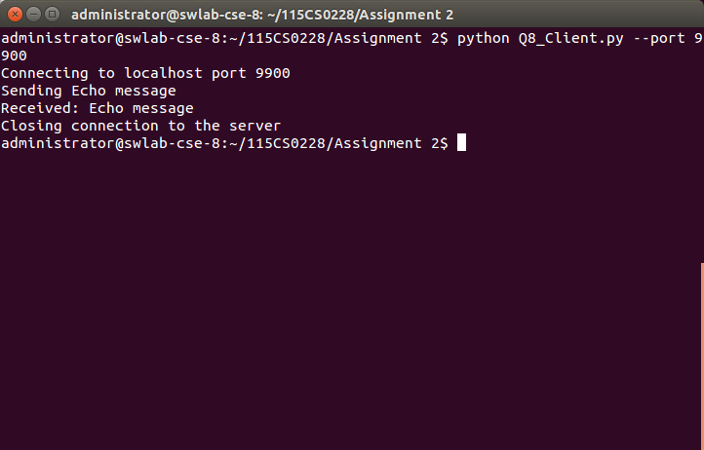
` SERVER SIDE
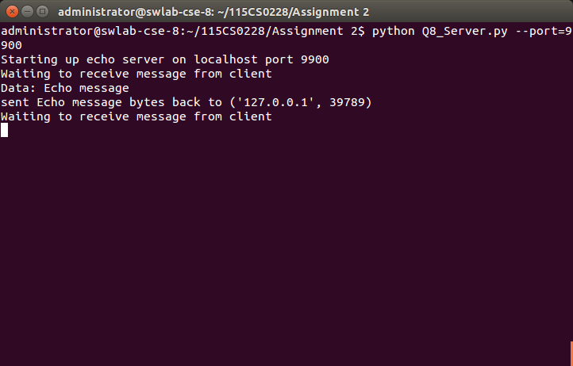
Q9. Write a simple UDP echo client/server application with the help of TCP socket object. The server wait for the client to be connected and send some data to the server. When the data is received, the server echoes the data to the client.

SERVER.PY
import socket
import sys
import argparse

host = 'localhost'
data_payload = 2048

def echo_server(port):
""" A simple echo server """
# Create a UDP socket
sock = socket.socket(socket.AF_INET, socket.SOCK_DGRAM)
# Bind the socket to the port
server_address = (host, port)

print ("Starting up echo server on %s port %s" % server_address)
sock.bind(server_address)
while True:
print ("Waiting to receive message from client")
data, address = sock.recvfrom(data_payload)
print ("received %s from %s bytes from %s" % (data, len(data), address))
print ("Data: %s" %data)
if data:
sent = sock.sendto(data, address)
print ("sent %s bytes back to %s" % (sent, address))

if __name__ == '__main__':
parser = argparse.ArgumentParser(description='Socket Server Example')
parser.add_argument('--port', action="store", dest="port", type=int, required=True)
given_args = parser.parse_args()
port = given_args.port
echo_server(port)

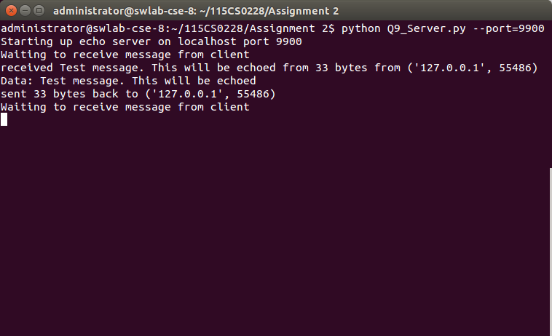
CLIENT.PY
import socket
import sys
import argparse

host = 'localhost'
data_payload = 2048

def echo_client(port):
""" A simple echo client """
# Create a UDP socket
sock = socket.socket(socket.AF_INET, socket.SOCK_DGRAM)
server_address = (host, port)
print ("Connecting to %s port %s" % server_address)
message = "This is a message"
try:
# Send data
message = "Test message. This will be echoed"
print ("Sending %s" % message)
sent = sock.sendto(message.encode('utf-8'), server_address)

# Receive response
data, server = sock.recvfrom(data_payload)
print ("received %s" % data)
finally:
print ("Closing connection to the server")
sock.close()

if __name__ == '__main__':
parser = argparse.ArgumentParser(description='Socket Server Example')
parser.add_argument('--port', action="store", dest="port", type=int, required=True)
given_args = parser.parse_args()
port = given_args.port
echo_client(port)

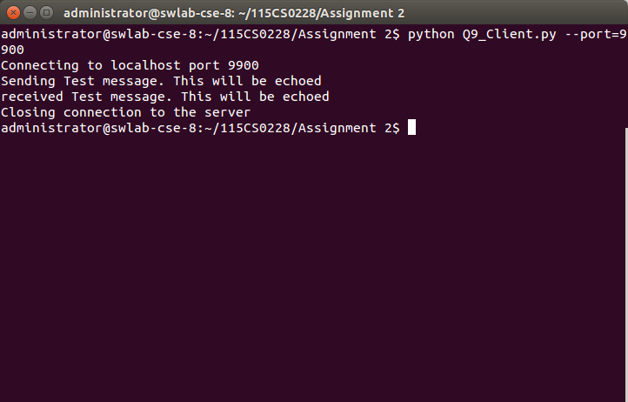
Q10. Write a program that is a TCP server that returns a HTTP response to a browser that displays
the client’s IP address and the number of times it has connected to the server. Test your program
with a standard Web browser like the Internet Explorer

CODE :

import socket

s = socket.socket()
host = socket.getfqdn()
port = 9082
s.bind((host, port))

print 'Starting server on', host, port
print 'The Web server URL for this would be http://%s:%d/' % (host, port)

s.listen(5)

print 'Entering infinite loop; Terminate manually to exit'

track = dict()

while True:
c, (client_host, client_port) = s.accept()
track[client_host] = track.get(client_host, 0) + 1
c.recv(1000)
c.send('HTTP/1.0 200 OK\n')
c.send('Content-Type: text/html\n')
c.send('\n')
c.send("""
<html>
<body>
<h1>Hello.</h1> Server Address : """+host+"""
</body>
</html>
""")
c.close()
print 'Got connection from', client_host, client_port, track[client_host], 'times'

